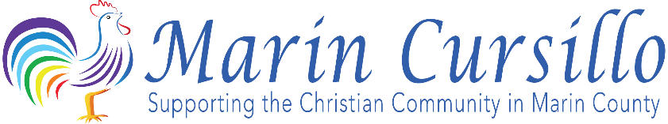 December, 2017

Dear Pastor Bob,
WE NEED YOUR HELP! AND IT IS OUR MISSION TO HELP YOU!
The Cursillo community has been an ecumenical presence in Marin for over 60 years and is sponsored jointly by the Roman Catholic Archdiocese and the Episcopal Diocese of California. Over 3 thousand Christian men and women have experienced a Cursillo weekend, including many of the clergy in this County, and we, the men and women of Marin who have experienced Cursillo, have returned to our respective churches committed to improving our spiritual lives and assisting our churches reach their ecclesiastical goals.
Cursillo, like the churches it serves, has encountered its ups and downs over the past several decades and we are currently engaged in a resurgence which we hope will energize our membership and reverse the increasing secularism that has characterized life in Marin for the past 20 years. We hope to reach out to the young adults of our church communities and intensify their desire to Christianize their personal lives, families, churches, and communities at large.
We need your help in guiding us to members of our Church who might be interested in a Cursillo weekend and experience firsthand the love of Christ and draw from that relationship the desire to be more active in the Church. We would be privileged to speak to you more about Cursillo and how we can assist you in reaching your goals and how you can help us in our work and will be calling you soon to arrange a convenient time to meet. Thank you for your past and continued support of Cursillo and we look forward to many years of working together to bring Christ’s love to all.
Respectfully,

The Marin Cursillo Community

